An Overview of the African-American Experience

An Overview of the African-American Experience
In the mid-1500s, European mariners started bringing black Africans to America as slaves. This forced migration was unique in American history.
But the slave trade was not new to Europe or Africa. In the eighth century, Moorish merchants traded humans as merchandise throughout the Mediterranean. In addition, many West African peoples kept slaves. West African slaves were usually prisoners of war, criminals, or the lowest-ranked members of caste systems.
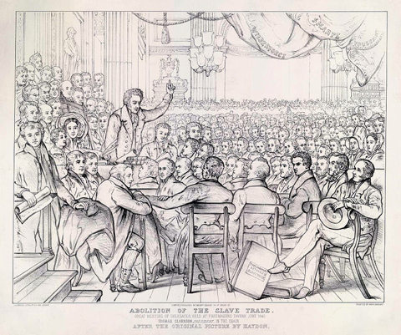
An engraving depicting the 1840 convention of the Anti-Slavery Society, held in London. People attended from around the world, including from the U.S. (Wikimedia Commons)
The capture and sale of Africans for the American slave markets were barbaric and often lethal. Two out of five West African captives died on the march to the Atlantic seacoast where they were sold to European slavers. On board the slave vessels, they were chained below decks in coffin-sized racks. An estimated one-third of these unfortunate individuals died at sea.
In America, they were sold at auction to owners, who wanted them primarily as plantation workers. Slave owners could punish slaves harshly. They could break up families by selling off family members.
Despite the hardships, slaves managed to develop a strong cultural identity. On plantations, all adults looked after all children. Although they risked separation, slaves frequently married and maintained strong family ties. Introduced to Christianity, they developed their own forms of worship.
Spirituals, the music of worship, expressed both slave endurance and religious belief. Slaves frequently altered the lyrics of spirituals to carry the hope of freedom or to celebrate resistance.
In time, African culture enriched much of American music, theater, and dance. African rhythms found their way into Christian hymns and European marches. The banjo evolved from an African stringed instrument. The sound of the blues is nothing more than a combination of African and European musical scales. Vaudeville was partially an extension of song-and-dance forms first performed by black street artists.

Abolition and Civil War
In the 17th and 18th centuries, some blacks gained their freedom, acquired property, and gained access to American society. Many moved to the North, where slavery, although still legal, was less of a presence. African Americans, both slave and free also made significant contributions to the economy and infrastructure working on roads, canals, and construction of cities.
By the early 1800s, many whites and free blacks in Northern states began to call for the abolition of slavery. Frederick Douglass, a young black laborer, was taught to read by his master’s wife in Baltimore. In 1838, Douglass escaped to Massachusetts, where he became a powerful writer, editor, and lecturer for the growing abolitionist movement.
Frederick Douglass knew that slavery was not the South’s burden to bear alone. The economy of the industrial North depended on the slave-based agriculture of the South. Douglass challenged his Northern audience to take up the cause against Southern slavery. “Are the great principles of political freedom and natural justice, embodied in the Declaration of Independence, extended to us?” he asked. “What to the American slave is your Fourth of July?”
When the Civil War began, many Northern blacks volunteered to fight for the Union. Some people expressed surprise at how fiercely black troops fought. But black soldiers were fighting for more than restoring the Union. They were fighting to liberate their people.

Reconstruction and Reaction
With the defeat of the Confederacy, Northern troops remained in the South to ensure the slaves newly won freedom. Blacks started their own churches and schools, purchased land, and voted themselves into office. By 1870, African Americans had sent 22 representatives to Congress.
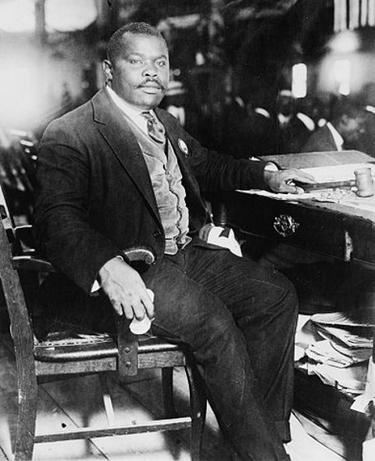
Marcus Garvey, a proponent of racial separation. (Wikimedia Commons)
But many Southerners soon reacted to black emancipation. Supported by the surviving white power structure, Ku Klux Klan members organized terrorist raids and lynchings. They burned homes, schools, and churches.
When Northern troops left in 1877, the white power structure returned. Within a couple of decades, this power structure succeeded in completely suppressing blacks. African Americans were excluded from voting. Southern states wrote Jim Crow laws that segregated blacks from white society. Blacks lived under constant threat of violence.

The Great Migration North
Beginning in the 1890s, many blacks started moving North. World War I opened many factory jobs. In the 1920s, strict new laws drastically cut European immigration. The drop in immigration created a demand for industrial workers in the Northern cities. Southern blacks, still oppressed by segregation, began to migrate northward in increasing numbers. Young black men eagerly took unskilled jobs in meat packing plants, steel mills, and on auto assembly lines in Chicago, Omaha, and Detroit.
Black workers unquestionably improved their lives in Northern cities. Indoor plumbing, gas heat, and nearby schools awaited many arrivals from the rural South. Discrimination also met them.
Yet black urban culture blossomed. Musicians like Louis Armstrong, Jelly Roll Morton, and King Oliver brought their music north from New Orleans. In the sophisticated urban atmosphere of Chicago, these jazz pioneers took advantage of improvements in musical instruments and new recording technologies to become celebrities in the Roaring ‘20s, also known as the Jazz Age.
Marcus Garvey, a Jamaican immigrant, preached black pride, racial separation, and a return to Africa. By the early 1920s, Garvey had an estimated 2 million followers, most of them Northern city-dwellers.
Harlem, an uptown New York City neighborhood, drew black migrants from the South. Black commerce and culture thrived in Harlem. After World War I, a group of black writers, artists, and intellectuals gathered there. Like Marcus Garvey, many sought cultural identity in their African origins. Unlike Garvey, however, they had no desire to return to Africa. They found creative energy in the struggle to be blacks and Americans.
This gathering of black artists and philosophers was called the Harlem Renaissance. Langston Hughes, a black novelist and poet, used the language of the ghetto and the rhythms of jazz to describe the African-American experience. Jazz continued its development as a uniquely American art form in Harlem, where prominent nightclubs like the Cotton Club featured great jazz composers like Duke Ellington and Fletcher Henderson. Their music lured whites uptown to Harlem to share the excitement of the Jazz Age. Zora Neale Hurston combined her writing ability with her study of anthropology to transform oral histories and rural black folk tales into exciting stories.
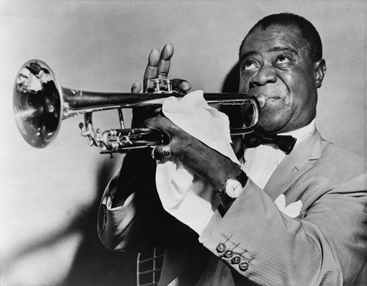
Jazz great Louis Armstrong. (Wikimedia Commons)
The Depression brought many blacks and whites together for the first time. In the cities, a half-million African Americans joined predominantly white labor unions. In the South, poor black and white farmers joined together in farmers’ unions.
In 1941, African-American author Richard Wright wrote, “We black folk, our history and our present being, are a mirror of all the manifold experiences of America. What we want, what we represent, what we endure is what America is.... The differences between black folk and white folk are not blood or color, and the ties that bind us are deeper than those that separate us. The common road of hope which we all traveled has brought us into a stronger kinship than any words, laws, or legal claims.”

Civil Rights Movement

Although we generally focus on the Civil Rights Movement that began in the 1950s and 1960s, the African American struggle for liberty and equality began much earlier, well before the Civil War. The system of chattel slavery that took hold in the Americas within a year of Christopher Columbus’s landing perpetually enslaved Africans, deprived them of basic human rights, and created an entrenched racial hierarchy. Throughout the colonial and antebellum eras, enslaved Africans defied this dehumanizing and violent system, often through acts of passive resistance that lessened the profits of slave-owners. But there were also overt acts of resistance, such as the slave revolts of 1822 led by Denmark Vesey (c.1767–1822) and of 1831 led by Nat Turner (1800–31). The Underground Railroad, a network of black and white antislavery advocates, helped slaves escape and travel to free states in the North. Whether remembered by name or not, enslaved and free African Americans asserted their dignity through acts of passive and explicit defiance and the formation of strong, independent communities.
One of the most famous spokesmen for the abolition of slavery and equal rights for African Americans was Frederick Douglass (1818–95). Born as a slave in Maryland, Douglass taught himself to read and write, and as a young man, escaped his abusive master and settled in the North. Douglass soon became involved in the abolitionist movement and after meeting William Lloyd Garrison (1805–79), became an antislavery lecturer and contributor to abolitionist newspapers. Some white critics doubted Douglass’s account of his enslavement and escape, not believing that a self-taught, former slave could be so eloquent. In response to these skeptics, Douglass wrote an autobiography, Narrative of the Life of Frederick Douglass, an American Slave (1845) which remains one of the most powerful and moving works about the evils of slavery and the reality of life for black Americans in the 19th century. (Douglass would go on to write two more autobiographies: My Bondage and My Freedom [1855] and Life and Times of Frederick Douglass [1881].)

The advocacy of abolitionists like Douglass and Garrison contributed to the end of slavery during and following the Civil War. Together, the Emancipation Proclamation (1863), as well as the Thirteenth (1865), Fourteenth (1868), and Fifteenth (1870) Amendments to the Constitution abolished slavery and declared that American citizenship and the right to vote could not be restricted on the basis of race.
In spite of the abolition of slavery and these constitutional changes, widespread discrimination and segregation persisted. Known as Jim Crow, this system of state and local laws, particularly in the former slave states of the American South, widely denied African Americans the right to vote, prevented them from accessing education and employment opportunities, and restricted the use of public facilities and transportation on the basis of race. African Americans still lacked the rights of citizenship afforded to white Americans and lived in highly segregated, underserved communities.
During the early twentieth century, African American leaders responded in different ways to the continuing legal entrenchment of racial hierarchy through the Jim Crow system. Booker T. Washington (1856–1915) was the most well-known African American thinker and educator in the late 19th and early 20th centuries. Washington was a member of the last generation of enslaved African Americans, born in Virginia ten years before the conclusion of the Civil War. Aware of the social and political realities of the Jim Crow South, Washington sought to promote racial progress apolitically, via black self-improvement obtained through education and the habits of self-command, avoiding actively antagonizing white leaders.
Washington’s philosophy, often called by others “racial accommodation” because it sought to elevate African Americans within existing segregated arrangements, increasingly drew criticism in the early twentieth century. Other African American leaders, particularly W. E. B. Du Bois (1868–1963), voiced criticism of Washington’s apolitical approach and his willingness to accept white hegemony. The first African American to earn a Ph.D. at Harvard University, Du Bois demanded that black and white citizens be afforded equal rights and sought to combat the racist system on which disenfranchisement rested. Du Bois helped found the National Association for the Advancement of Colored People (NAACP), which became the most influential and powerful African American advocacy group during the early twentieth century, and he remained the editor of its newspaper, The Crisis.¹

With the founding of the NAACP in 1909, a more formal struggle for civil rights that coordinated political, social, and legal resistance to Jim Crow began. The NAACP advocated for the right of African Americans to serve in the US military during World War I and began to coordinate and fund legal challenges to Jim Crow laws. Between the First and Second World Wars, the NAACP challenged laws across the country that denied African Americans their full rights of citizenship and sought federal legislation to protect against lynching, establishing the Legal Defense Fund in 1939 for this express purpose.
The three decades following World War II, often known as the Civil Rights Era, witnessed dramatic changes in American political and social culture. In addition to the NAACP, numerous other groups emerged to fight for equal rights for African Americans. Their efforts, along with the bravery and dedication of countless individuals, helped strike down laws that enforced segregation and discrimination, and inspired the passage of new legislation that afforded greater protection to African American citizens.
Exploiting the hypocrisy of asking African Americans to give their lives in the service of their county while segregating their units, the Legal Defense Fund secured the desegregation of the Armed Servicesin 1948. Their success in desegregating public spaces and services continued in the landmark Supreme Court decision, Brown v. Board of Education in 1954, argued by Thurgood Marshall, who would later become the first African American Supreme Court Justice. The court ruled that the guiding principle of segregation—separate but equal—was unconstitutional, and it ordered the integration of schools across the country.
The court’s decision was enforced, and schools were integrated despite local resistance across the South. In 1957, the Governor of Arkansas Orval Faubus (1910–54) ordered the National Guard to bar nine black students from attending the formerly all-white Central High School in Little Rock, in defiance of the Supreme Court’s ruling. In response, President Dwight D. Eisenhower deployed federal troops to accompany the students and enforce integration. In the early 1960s, there were several more instances of conflict when black students trying to enter formerly white universities faced armed opposition and required the protection of federal troops.

Other African American individuals and groups used nonviolent protests and civil disobedience to fight discrimination. On December 1, 1955, Rosa Parks, a black seamstress and secretary of the local chapter of the NAACP, refused to give up her seat for a white man on a bus in Montgomery, Alabama, and was arrested, tried, and fined. Parks’ act inspired the Montgomery Bus Boycott, during which tens of thousands of black residents refused to use the bus system in Montgomery. The protest lasted for 381 days, until the Supreme Court ruled that the segregation of public transit systems was unconstitutional.
The Montgomery Bus Boycott inspired similar acts of collective civil disobedience to challenge discriminatory local laws. Four black students in Greensboro, North Carolina staged a sit-in at a Woolworth’s lunch counter that only served whites. Their protest soon gained the support of hundreds of other students, both black and white, in Greensboro, and it sparked similar protests against segregated restaurants and commercial spaces. Widespread news coverage and the economic toll of the demonstrations forced businesses across the South to begin integrating in the summer of 1960.

Encouraged by the success of the sit-ins, students founded the Student Nonviolent Coordinating Committee (SNCC), which organized student nonviolent protests against discrimination and segregation. SNCC, along with the Congress of Racial Equality (CORE), initiated “Freedom Rides,” in which black and white activists rode buses through the South to test the 1960 Supreme Court ruling that interstate transport could not be segregated. Their efforts faced violent opposition; many of the students were attacked, beaten, and jailed.
Outside volunteers were far from the only victims of racial violence. In one of the most horrific acts of brutality, the Sixteenth Street Baptist Church in Birmingham, Alabama, a common meeting place for local civil rights leaders, was bombed on September 15, 1963. The explosion early on a Sunday morningkilled four young girls—Addie Mae Collins (age 14), Denise McNair (age 11), Carole Robertson (age 14), and Cynthia Wesley (age 14)—and injured many others.
In addition to desegregation, voter registration became an important goal for the Civil Rights Movement. Across the South, African Americans largely remained disenfranchised through poll taxes, literacy tests, and other onerous requirements intended to prevent them from voting. In 1961, several national civil rights organizations began coordinating with African American community leaders to begin registering black voters. The united efforts of the NAACP, SNCC, CORE, and the Southern Christian Leadership Conference (SCLC) intensified in the summer of 1964, known as the Mississippi Freedom Summer, during which student volunteers, most of whom were white, registered black voters across Mississippi. Their efforts encountered fierce and often violent opposition from local whites and resulted in the deaths of at least three volunteers, as well as social and economic repercussions for African Americans who tried to register to vote.
Movement organizers also used widely publicized marches to draw national attention to the political and social inequalities faced by African Americans and to increase public support for the Movement’s efforts. The famous March on Washington in August of 1963 attracted more than 200,000 protesters, who gathered at the Lincoln Memorial to hear Martin Luther King Jr. deliver his “I Have a Dream” speech. King also helped to organize another important march two years later, the 1965 March from Selma to Montgomery, which called for equal voting rights. Media coverage of the campaigns and public outrage over racial violence strengthened national support for the Civil Rights Movement and put pressure on the federal government to offer greater protection for the rights of black citizens.
In response, Congress passed two landmark pieces of legislation: the Civil Rights Act (1964) and the Voting Rights Act (1965). First proposed by President John F. Kennedy and signed into law after his death by President Lyndon B. Johnson, the Civil Rights Act broadly prohibited discrimination on the basis of race, color, sex, religion, or national origin and invalidated any state or local laws that had previously enforced discriminatory practices. The Voting Rights Act disallowed the numerous restrictions on voting rights that localities had used to exclude African Americans from the franchise. Together, these pieces of legislation solidified the efforts of grassroots organizations and individuals who fought to end segregation, disenfranchisement, and segregation.
With the political rights of blacks protected by federal law, African American leaders began to shift their focus to other social and economic issues, such as increasing employment and housing opportunities. Many black communities, especially those outside the South, remained angered by persistent social and economic inequality, a feeling perhaps most clearly expressed in the Watts Riots, which broke out in Los Angeles in 1965. Six days of rioting injured more than a thousand people and resulted in several thousand arrests. King became a vocal opponent of the continuing social and economic inequality, and following his assassination in 1968, riots again broke out in cities across the country. In response, Congress passed the final major piece of civil rights legislation, the Civil Rights Act of 1968. Commonly known as the Fair Housing Act, this law offered greater protection against discrimination for Americans of all races, genders, nationalities, and religions in their efforts to rent, own, and finance their homes.

The Rise of Black Power

Even before King’s death, dissatisfaction and frustration over persistent social and economic inequalities led to factions within the Civil Rights Movement. The most influential figure for a more militant brand of black activism was Malcolm X (born Malcolm Little; 1925–65). Little converted to the Nation of Islam, a religious group that inflected Islam with teachings of black supremacy, and took the surname “X” to signify that while he would never know his true African ancestry, he had “replaced the white slavemaster name of ‘Little.’” Malcolm X rose quickly through the ranks of the Nation of Islam and became one of the group’s most vocal and visible spokesmen in the late 1950s and early 1960s, advocating the separation of black communities from mainstream white society.

In March 1964, Malcolm X announced his break with the Nation of Islam. After returning from a pilgrimage to Mecca, he adopted radically different ideas. He began practicing Sunni Islam, and came to see the faith as a religion of racial unity and equality. Malcolm X was assassinated by members of the Nation of Islam in 1965, but his posthumous autobiography became extremely influential.
Other black leaders began to question the Movement’s commitment to nonviolence and its goal of integration and found a new direction in the ideology of “Black Power” expressed by Malcolm X. Stokely Carmichael (1941–98), who became head of the SNCC in 1966, challenged the philosophy of nonviolence by responding to white violence with an equal show of force, and argued that blacks should focus on economic and cultural independence rather than integration into white society. Another group influenced by the teachings of Malcolm X, the Black Panther Party, formed in Oakland, California in 1966 by Huey Newton (1942–89) and Bobby Seale (b. 1937), espoused more militant views and advocated Black Nationalism, a belief in establishing the independence of African American communities to combat the economic plight and racism they faced. Although the Black Power movement eventually became publicly quiescent, the ideas and example of Malcolm X still command considerable attention in African American communities and on college campuses.

Source: https://www.whatsoproudlywehail.org/curriculum/the-american-calendar/a-brief-history-of-the-civil-rights-movement

https://www.crf-usa.org/black-history-month/an-overview-of-the-african-american-experience

For Further Reading
Ash, Stephen V. The Black Experience in the Civil War South (Reflections on the Civil War Era). Santa Barbara: Praeger. 2010.
Foner, Eric. Forever Free: The Story of Emancipation and Reconstruction. New York: Random House. 2005.

